Hand Print Tree

Supplies: Brown, Green, and blue Construction paper, pom poms, glue, scissors, Pencil

Directions:
- Trace Arm and hand onto brown construction paper and cut out to create the tree trunk
- Glue trunk onto blue sky
- Rip green paper into pieces to form the leaves and glue onto trunk
- Glue pom pom “fruit” onto tree and decorate

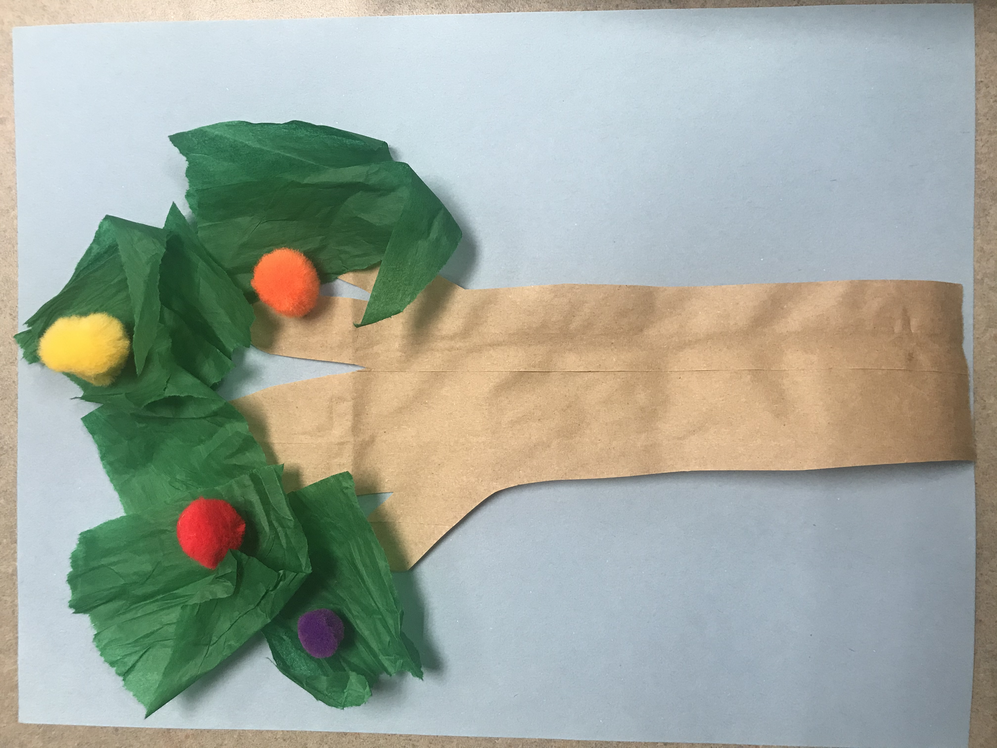

Egg Carton Planter

Supplies: Egg Carton, Stickers, Seeds, Soil, Markers

Directions:
- Decorate egg carton
- Place soil and seeds into your “pot”
- Place by a sunny window
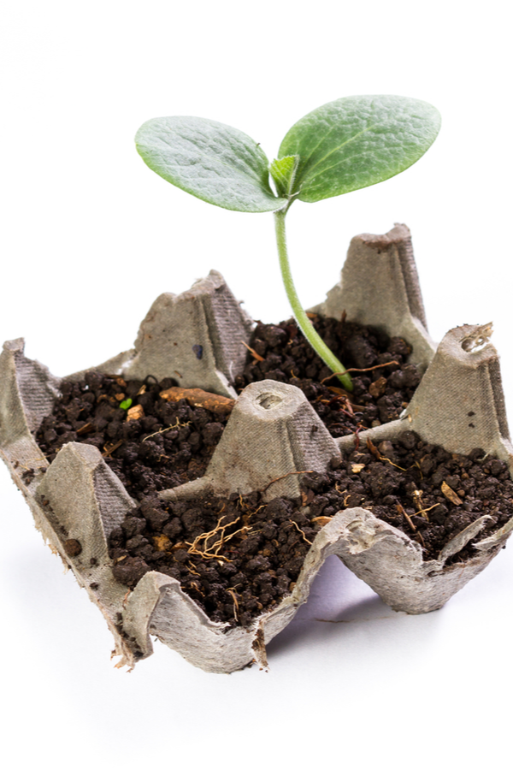
- Water and watch your plant grow!

